

electronic Customs management system
User Guide

On

dECLARATION- CFA

Version: 1.0
Date: 05/09/2022

About Yang Khor Pvt Ltd

Yang Khor IT Solutions is a leading In-country Technology Solutions Provider providing solution in terms of hardware, software, support, and services as its complete package.
Yang Khor IT Solutions has been serving its purpose since 2005, it now has emerged to be an unprecedented leader as a Solution Integrator with a differentiated vertical approach to providing innovative solutions. Yang Khor uses its solution integration capabilities to integrate best-of-breed products through its key technology alliance partners to provide “End to End” solutions. Provide customized business solutions that help organizations accelerate revenue growth, increase market penetration, optimize operating costs and improve employee productivity, by embedding communication in their business processes.

Yang Khor IT Solutions has achieved to be the Gold Partner of HPE, Service One Partner of HPE, Microsoft Silver Partner and VMWARE Professional Partner and having this Partnership we are able to serve the best of solution to our clients. Yang Khor IT Solution initially focuses on providing the best solution in terms of hardware and software, to serve the purpose of making life better with the Advance Technology which the world is moving forward with.

DOCUMENT HISTORY
S.No | Date | Version. No | Description | Approved By
1 | 05/09/2022 | 1.0 | First Release

Contents
- A. Chapter 1- About This Guide 4
Purpose and Audience 4
Document Conventions 4
- B. Chapter 2- Getting Started 5
End-user experience of the self-service process 5
1. Logging In 5
1.1. Forgot/Reset password? 7
- C. Chapter 3- Create Road Manifest. 10
D. To Create Road Manifest 10
B. Search Road Manifest 14
C. Cancel Road Manifest 16
- Chapter 4- Logging Out 17

Chapter 1- About This Guide
Welcome to the Trade Facilitation Baseline Customs Management System (eCMS) user guide for CFA USER! This user guide aims to enumerate the process and steps involved in using eCMS.
This user guide is divided into different topics and sub-topics. Each topic discusses and shows the steps of the modules that the eCMS.

Purpose and Audience
This user guide will help the user to get a quick reference on usage of the system.

Document Conventions
Refer to this section to familiarise yourself with the visual aids used throughout the user guide.
Navigation
To assist you with accessing screens, pages, or windows, refer to the following navigation format:
Click User Registration>>Users
Buttons, fields, and other system elements
All system elements are highlighted in Bold text.
Hyperlinks
All topics mentioned in the user guide’s content are hyperlinked. Click on the hyperlink to view the referenced topic.
Callouts
Callouts are presented differently from the original CONTENTS and highlight certain information.
There are two types of callouts: tips and warnings.

@ | A Tip provides useful information that helps you complete a task or procedure.

! | A Warning refers to information that may be critical to the system’s functionality and might affect data or system stability.

Chapter 2- Getting Started
Refer to this chapter to familiarize yourself with the eCMS System; how to log in and log off from the system.

End-user experience of the self-service process

Logging In
To log in to the eCMS:
- Type in URL http://uat.ecms.gov.bt/ECMSFE/login/indexBhutan.jsp in your Internet browser to access the eCMS System.
- eCMS Front End landing page will display

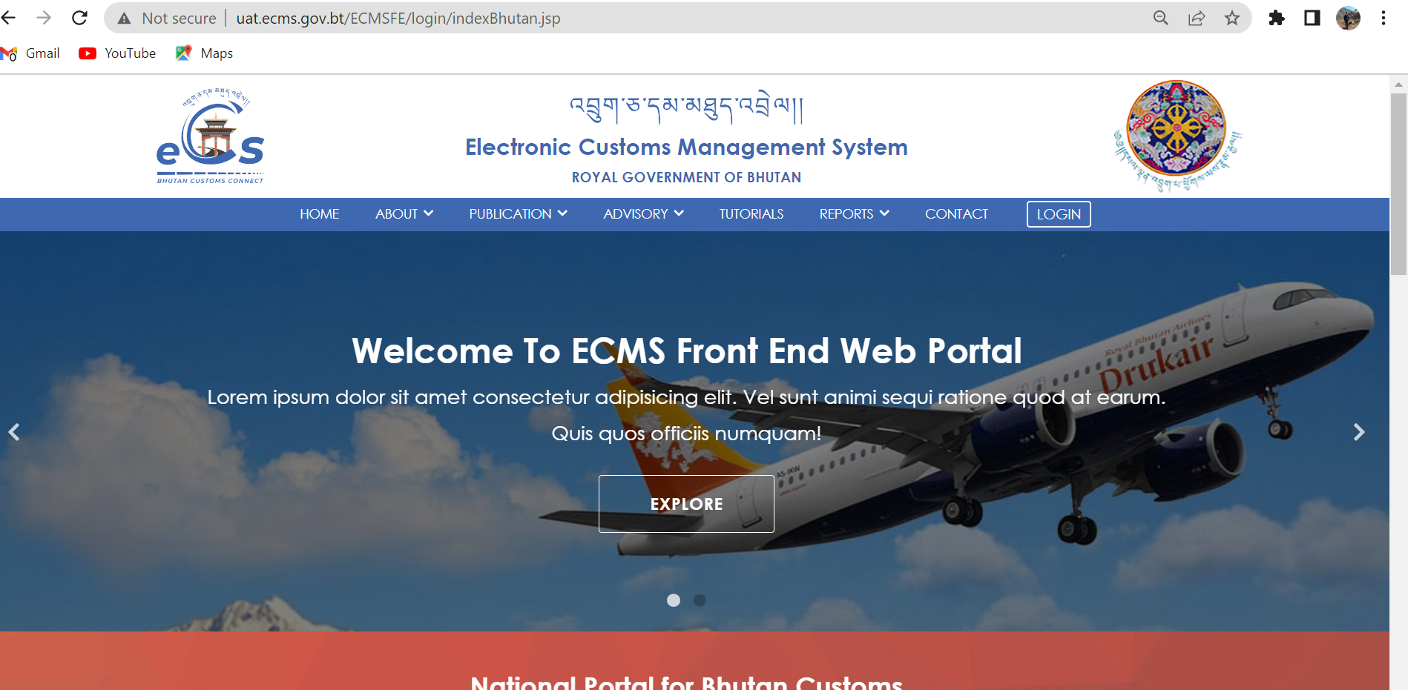

Fig.1. eCMS Landing page
Click>>> LOGIN

  - Click >>LOGIN, the following screen (Figure 2) will be displayed
eCMS Login

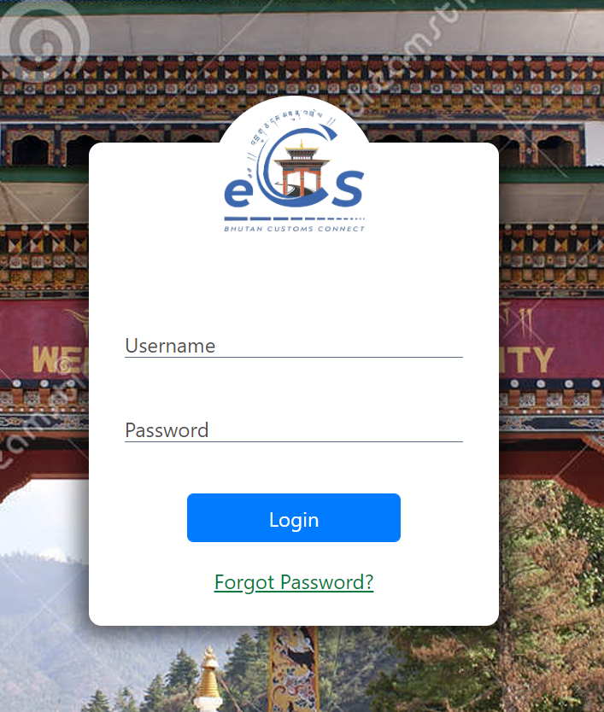
fig.2. eCMS login Page

  - Enter the USERNAME and the PASSWORD in the fields provided and Click button.

@ | In case you need to reset or forgot your password, On the login page, the user clicks the Forgot Password? link to start the process. The new password will be sent to your registered email.

Forgot/Reset password?
- If User Password is expired or forgot , Click >>“Forgot Password?”, “Forgot password Form” is displayed as shown in the figure 3 above.

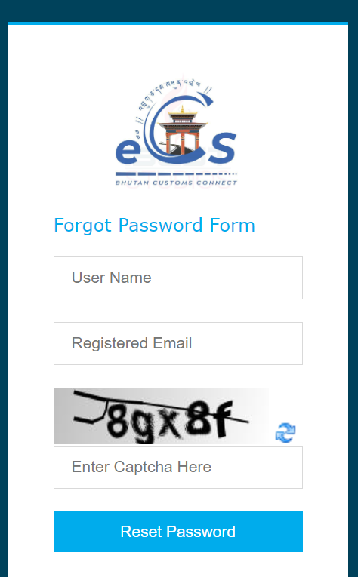
Fig.2. Forgot Password Form.
- Fill in the required details “User Name”, “Registered Email”, “Enter Captcha” and click on “Reset Password” Buttom. The subsequent screen is displayed;
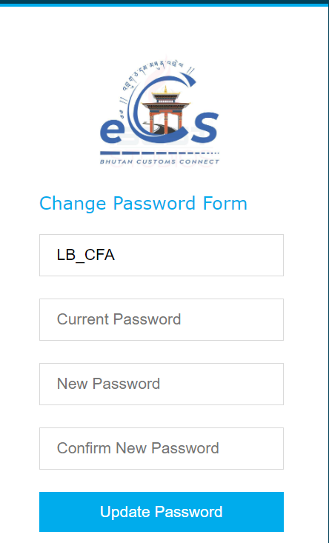
Fig.3. Update password

- Check your email for the password provided by the system and input in “Current Password” Field.
- Set your New Password and Confirm New Password.

- Click >> Update Password, the initial login page is displayed as below;


Fig.4. eCMS Login Page
- Enter the USERNAME and the NEW PASSWORD in the fields provided and Click “LOGIN” button.

Click>> LOGIN

- Upon successful login the Electronic Customs Management System Home Page will be displayed as shown below.
Dashboard Page

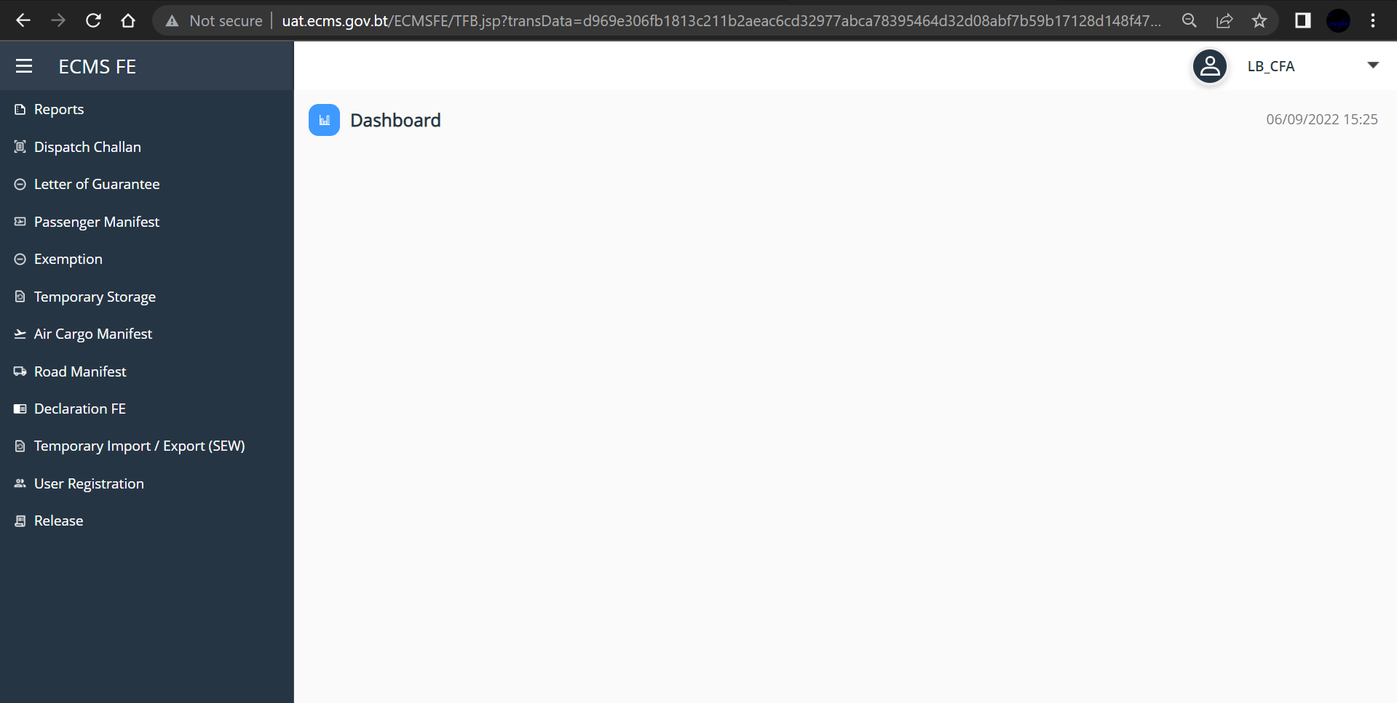
Fig.5. eCMS Dashboard

Chapter 3- DECLARATION.

To Create Declaration
- Go to Declaration in the menu and click on “Create Declaration”. Below given dashboard is shown
- General Information
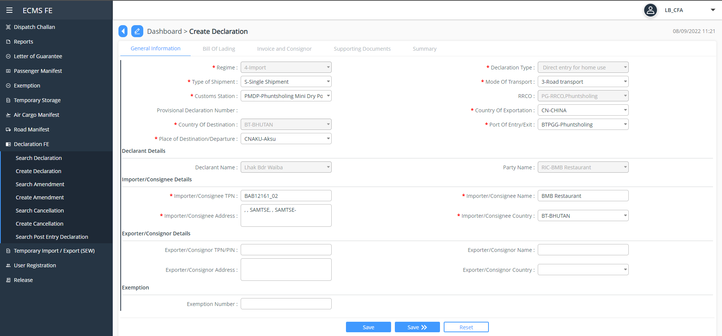
Fig.6. General Information.
- Select and fill in all the mandatory field.
- Clicking “Save>>” button
@ | Clicking “Save” button will save the information you input. Whereas,  Clicking “>>Save” button will Save the information you input as well as take you to next step.  Clicking “Reset” button will allow the user to reset and input new data.

Click “Save>>”
- Bill of lading
- Click on the “” available on the top right corner of the dashboard to add bill of lading, below screen will be displayed
- Fill in all the mandatory field and Click “Save>>” button to save and go to next
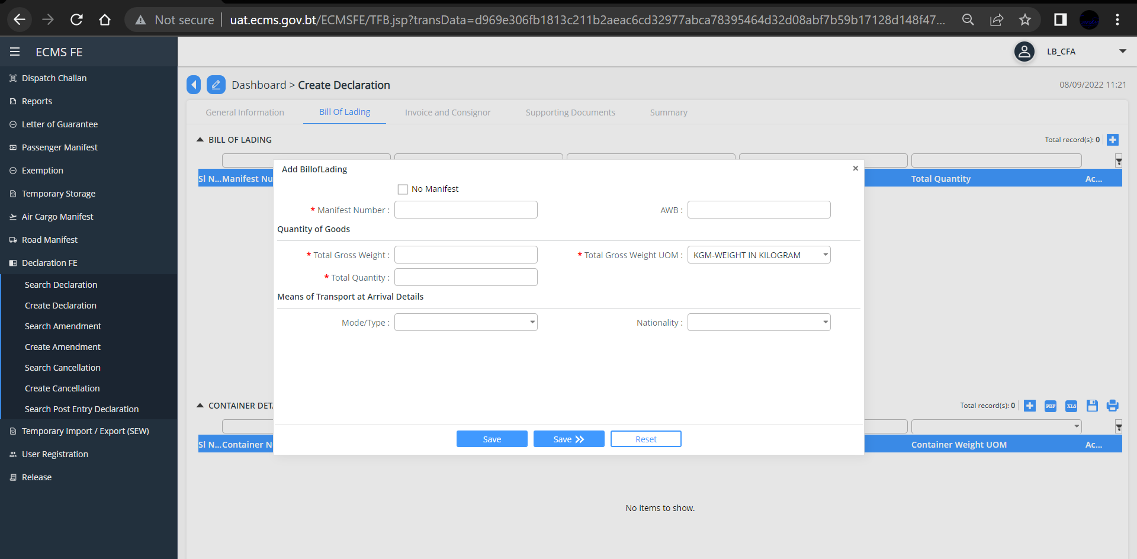
Fig.7. Bill of lading

Click “Save>>”
- Invoice and Consigner
- Fill in all the mandatory field and Click “Save>>” button
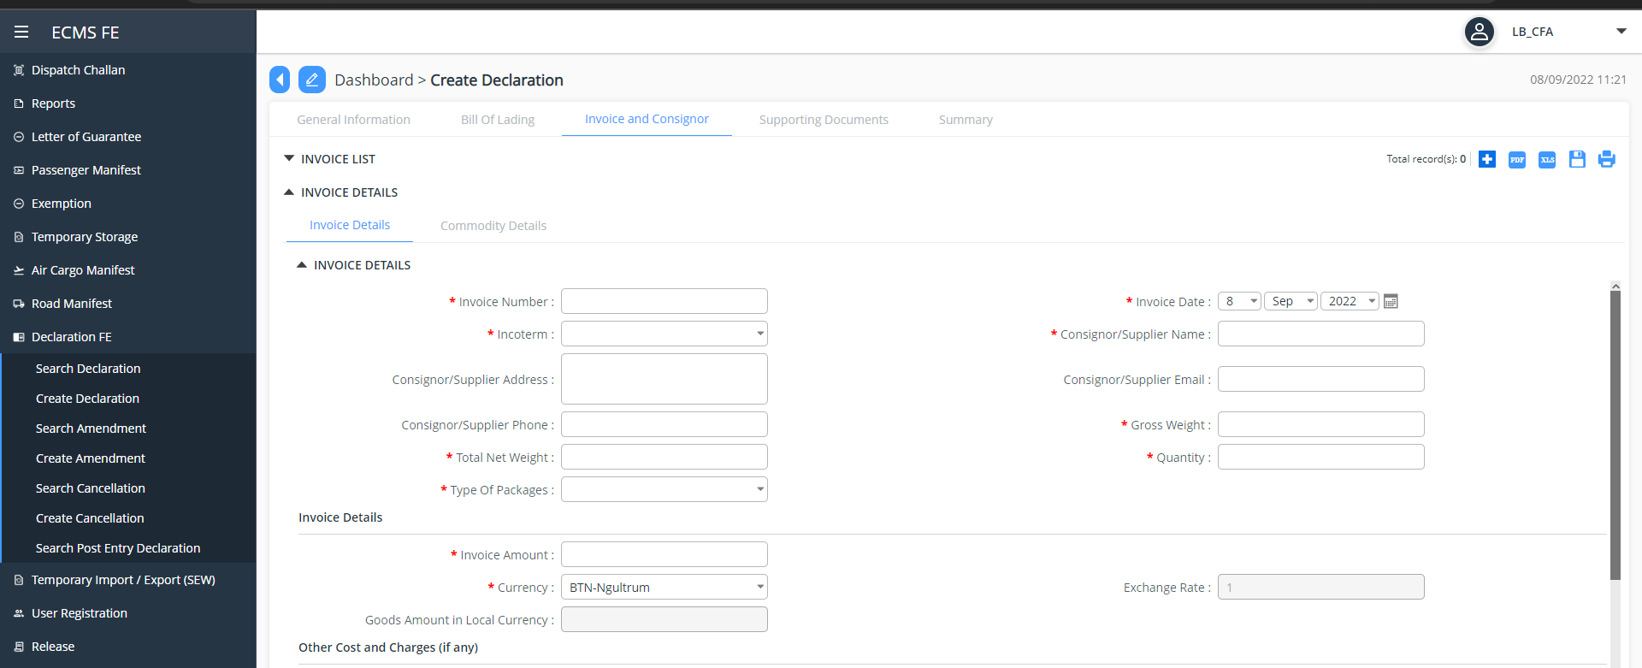
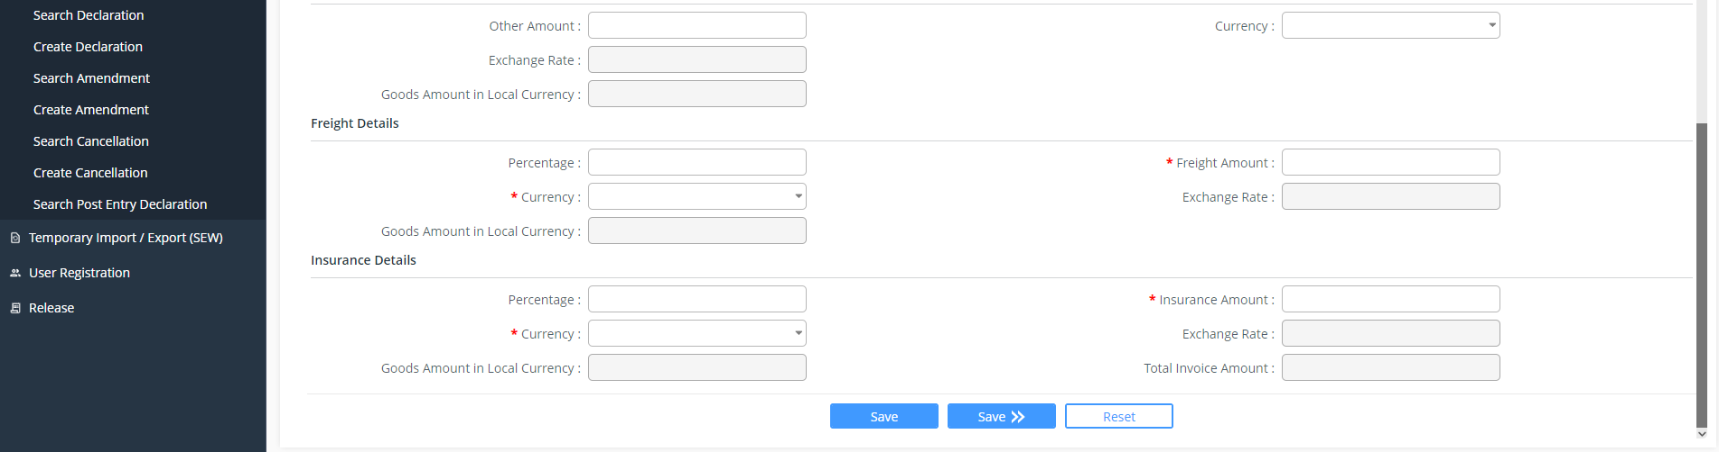
Fig.8. Invoice and Consigner
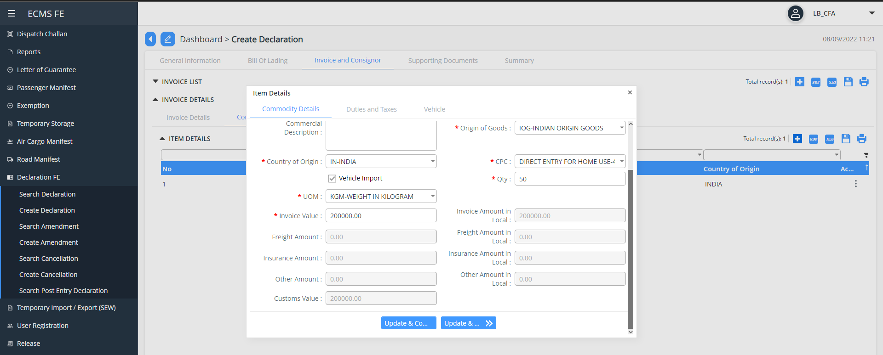
Fig. 9. Commodity details
- Add commodity details and click “Save and compute tax” button

- Update the vehicle details in the vehicle menu
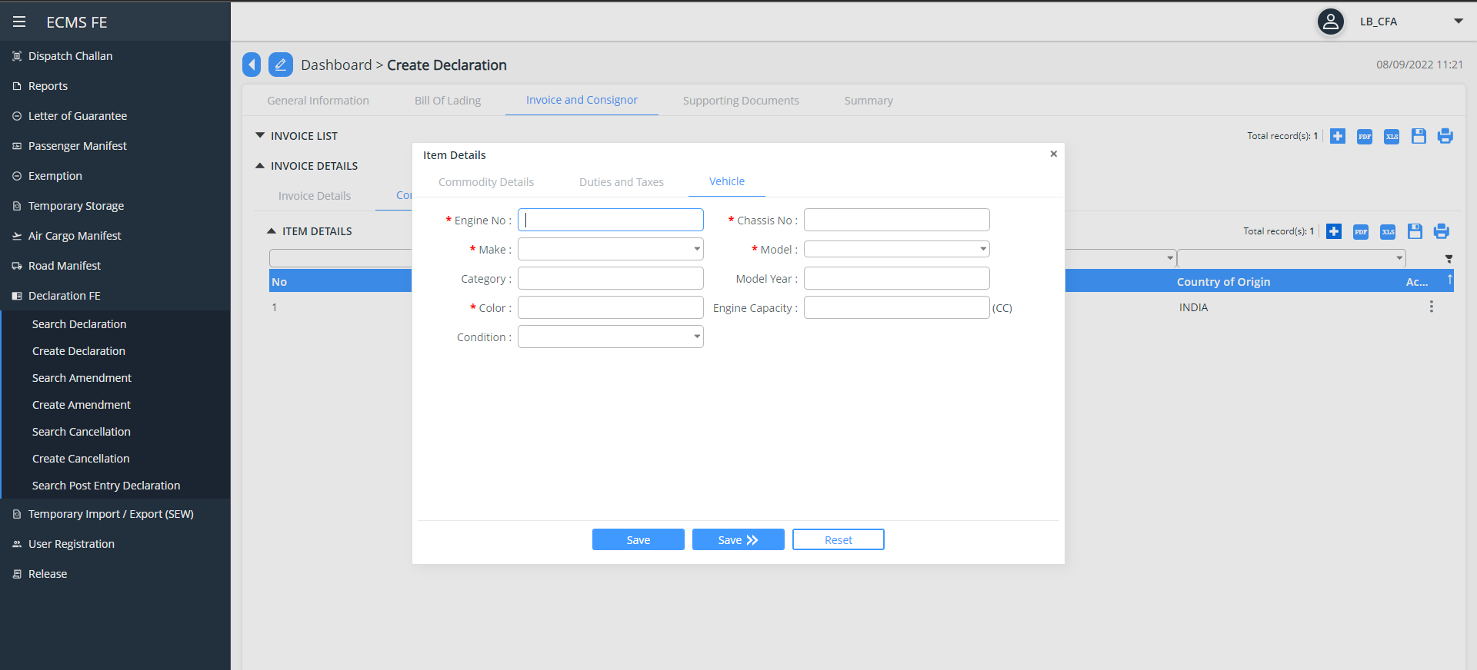
Fig.10. Update Vehicle details
@ | Clicking “Save” button will save the information you input. Whereas,  Clicking “>>Save” button will Save the information you input as well as take you to next step.  Clicking “Reset” button will allow the user to reset and input new data.
- Click “Save>>” Button to save your input and go to next i.e “Supporting Document”
- To add upload your supporting document (invoice), double click on the “invoice” in blue line or click on the three-dot available on extreme right of the invoice and choose and upload the document format in PDF/jpg/jpeg.
- If you have more than one invoice, you can add the by clicking on “” button available on the top right corner of the Dashboard.
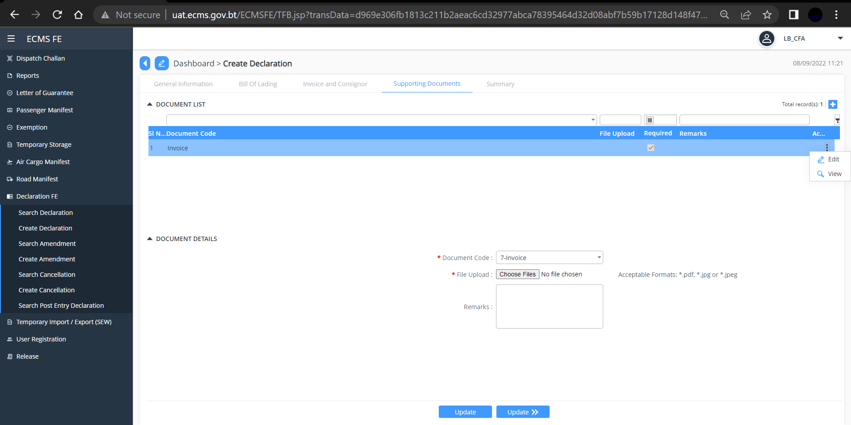Fig. 11. Upload Supporting Document

- Click “Update>>” button, you will reach to “Summary” as shown below.
- Tick on the DISCLAIMER box and click “validate” button to validate your input data
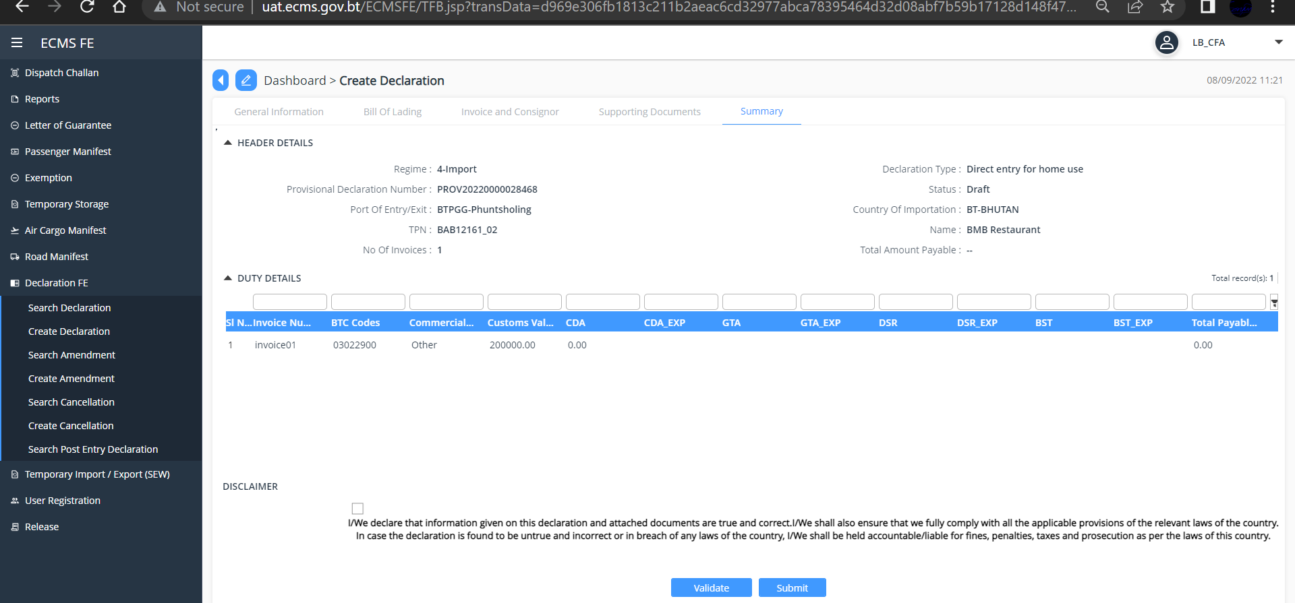
Fig. 12. Validate and Submit Declaration.

- Click “Submit” Button, a successful Declaration Submission Message pops up with the Declaration Number.
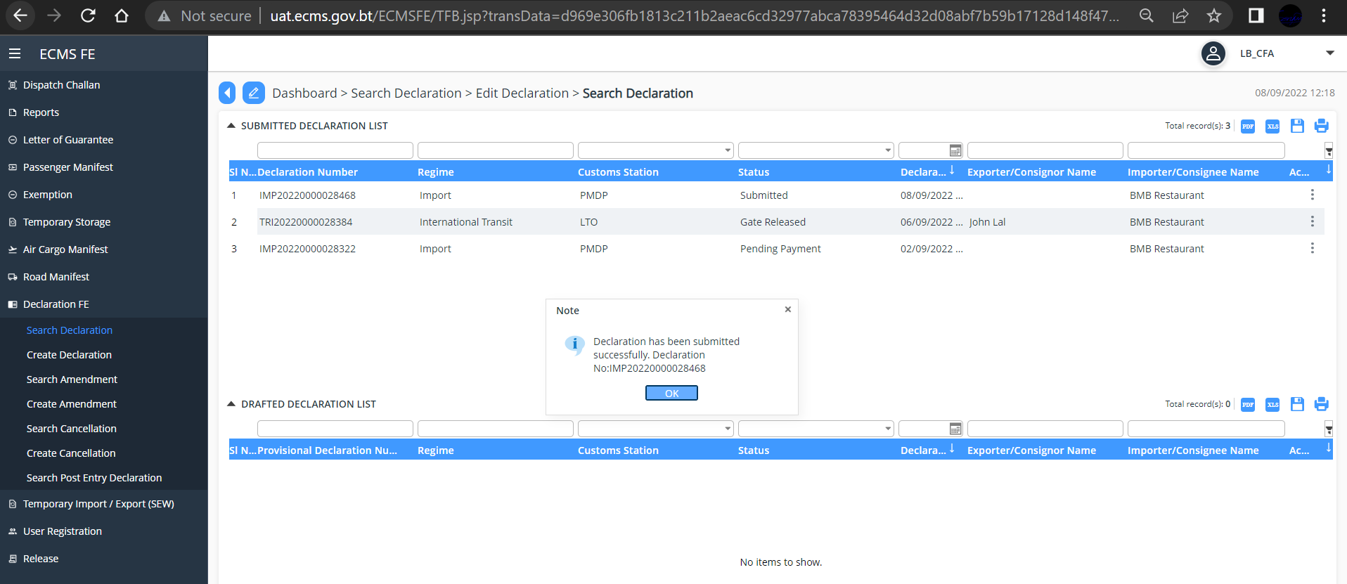
Fig. 13. Submit Declaration Successful Message

B. Search Declaration
- Go to Declaration menu and click on “Search Declaration”. Below given screen is shown. If you have submitted multiple Declaration, there will be multiple lists. Those manifest that you have not submitted will be listed under “DRAFTED ROAD MANIFEST”
- Enter/type in the Declaration number in the Declaration number Field and press enter
- Your Declaration will be displayed. Double click on the manifest to view the details you saved/Submitted. OR you can also view the document by clicking on the three dots present on the extreme right of the manifest.

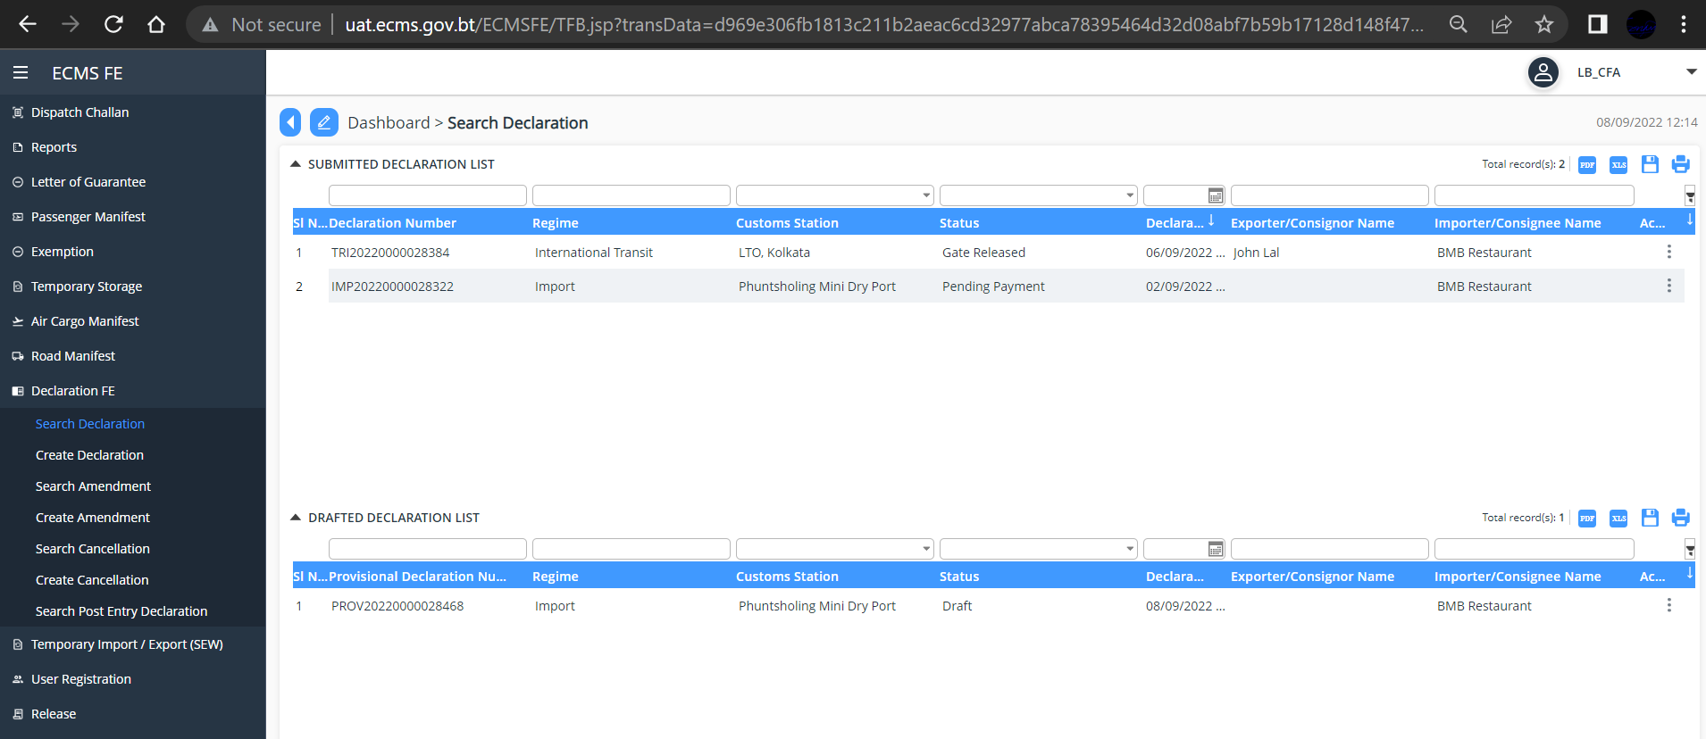
Fig. 14. Search Declaration
- You can view/print/clone the Declaration.
- To view, click>> “View” available on clicking the three dot on the extreme right of the Declaration, subsequent screen is displayed.
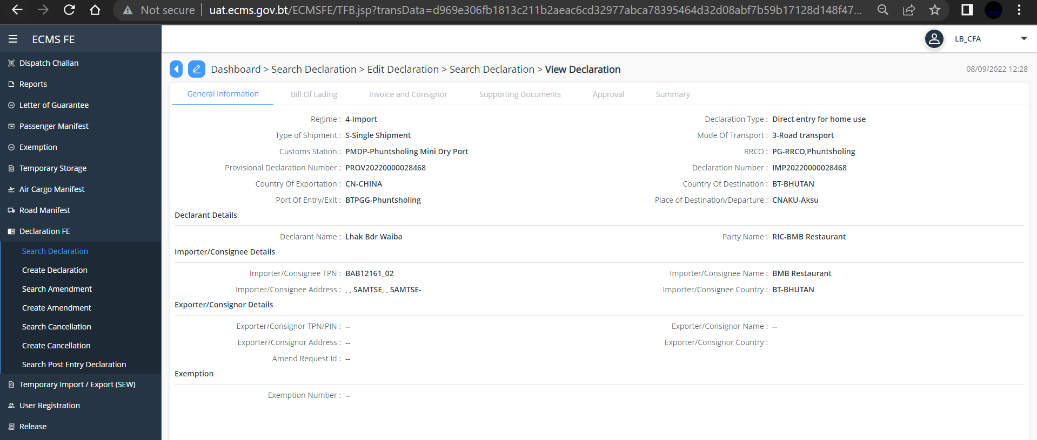
Fig. 15. View Road Manifest Details you submitted.
- To Print, click>> “Print”, your manifest will get downloaded for print
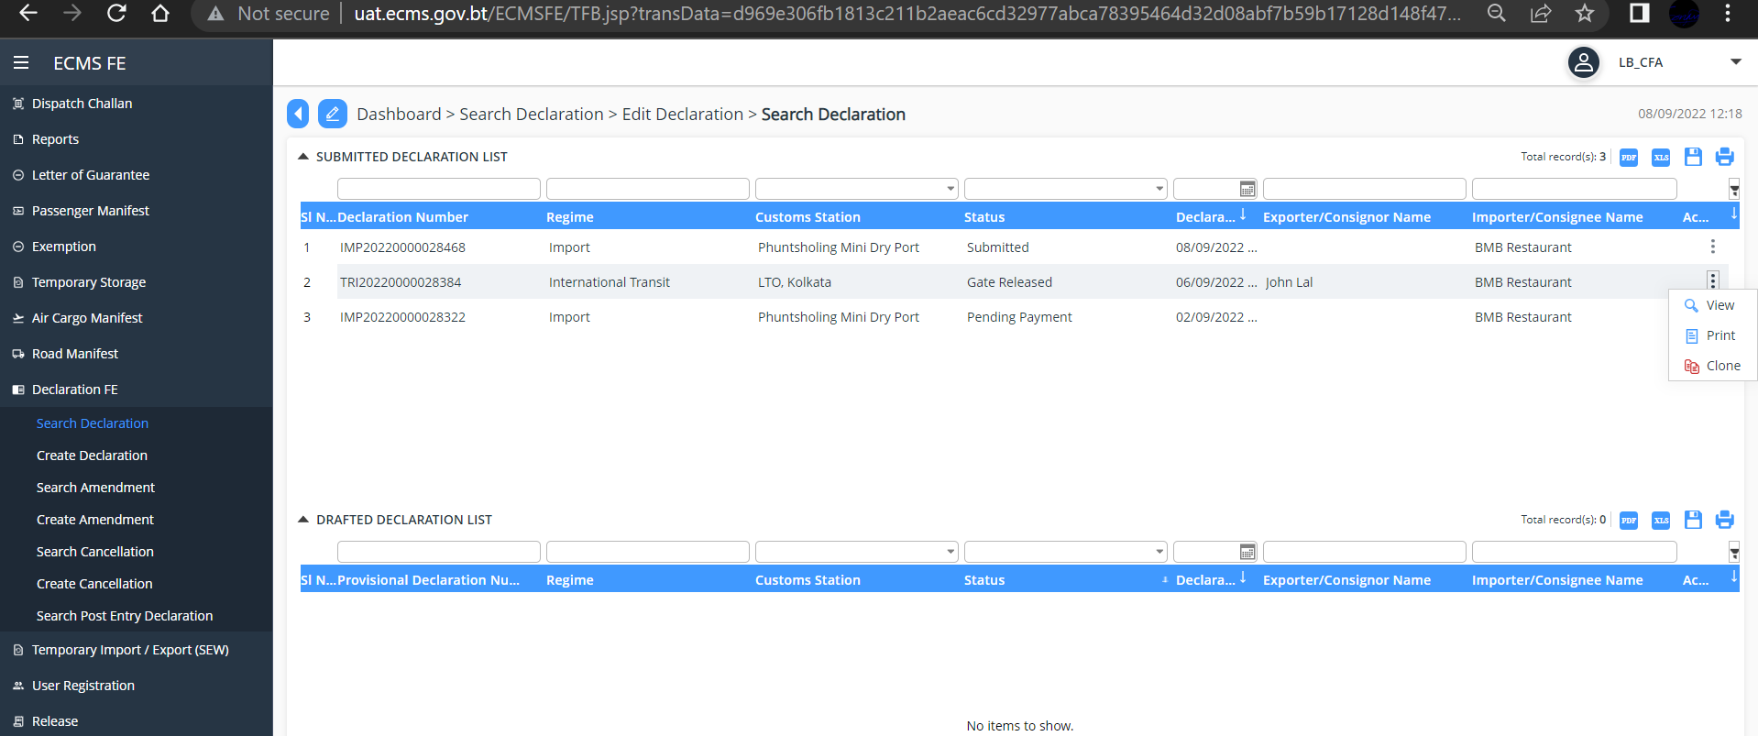
- To Clone, click>> “Clone”, your Declaration is cloned and provided Declaration number and is listed under “DRAFTED DECLARATION LIST” as shown in below screen.
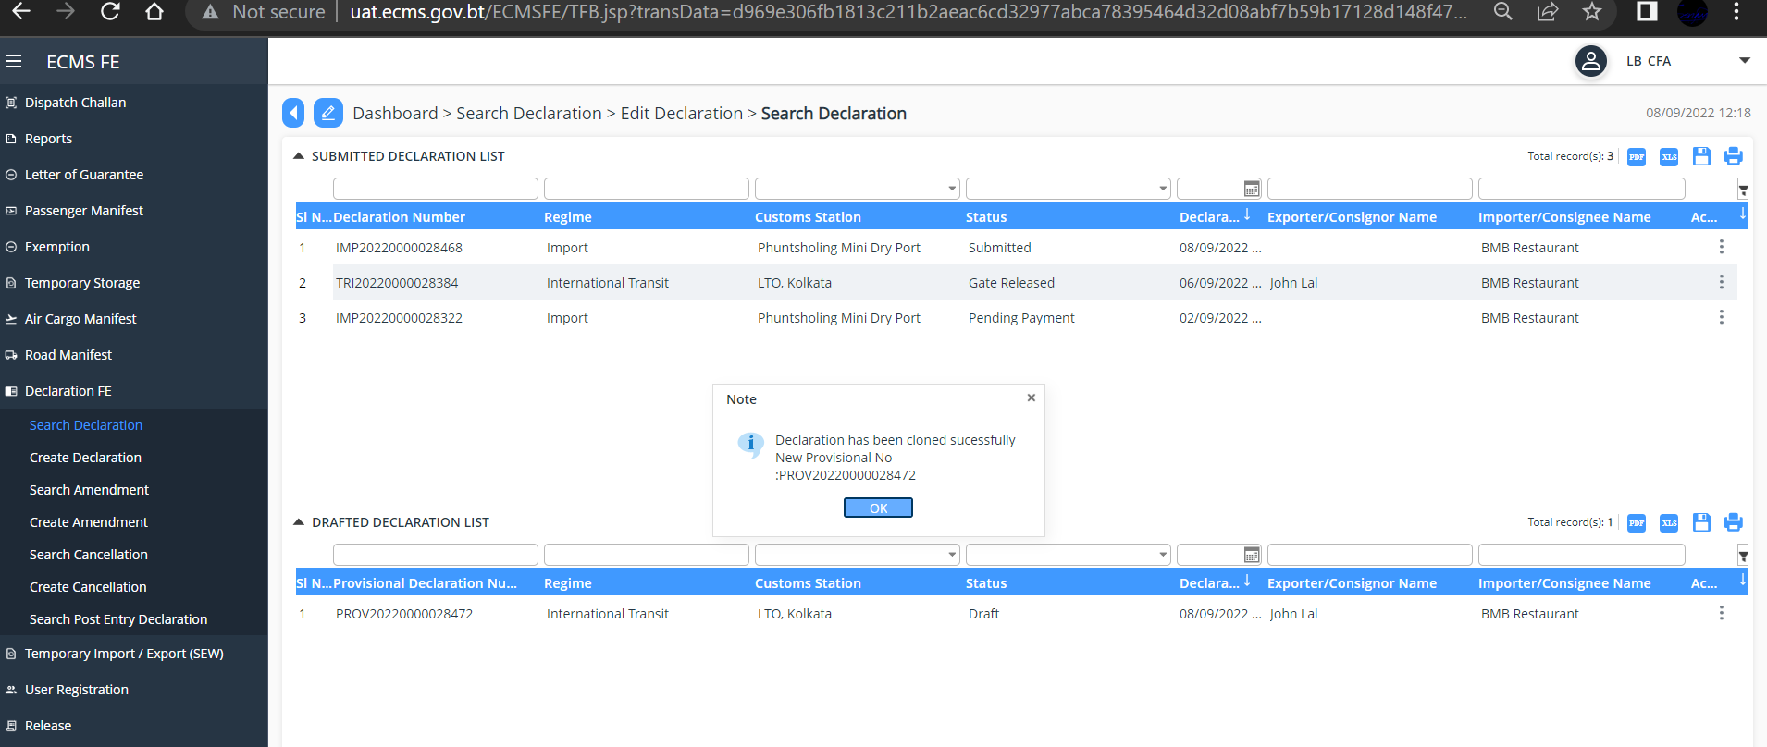

Fig.16. Clone Road Manifest

- To submit your Cloned New Road Manifest, view the Declaration, update data and click “Submit”. Your Declaration will get submitted for Approval.

C. Cancel Road Manifest

To Cancel the Road Manifest
- Go to Road manifest on the menu and click on “Cancel Road Manifest”. Below given screen is shown with the list of Road Manifest
- Search the Road manifest to be Cancelled with the Road manifest Number. Road Manifest will be displayed
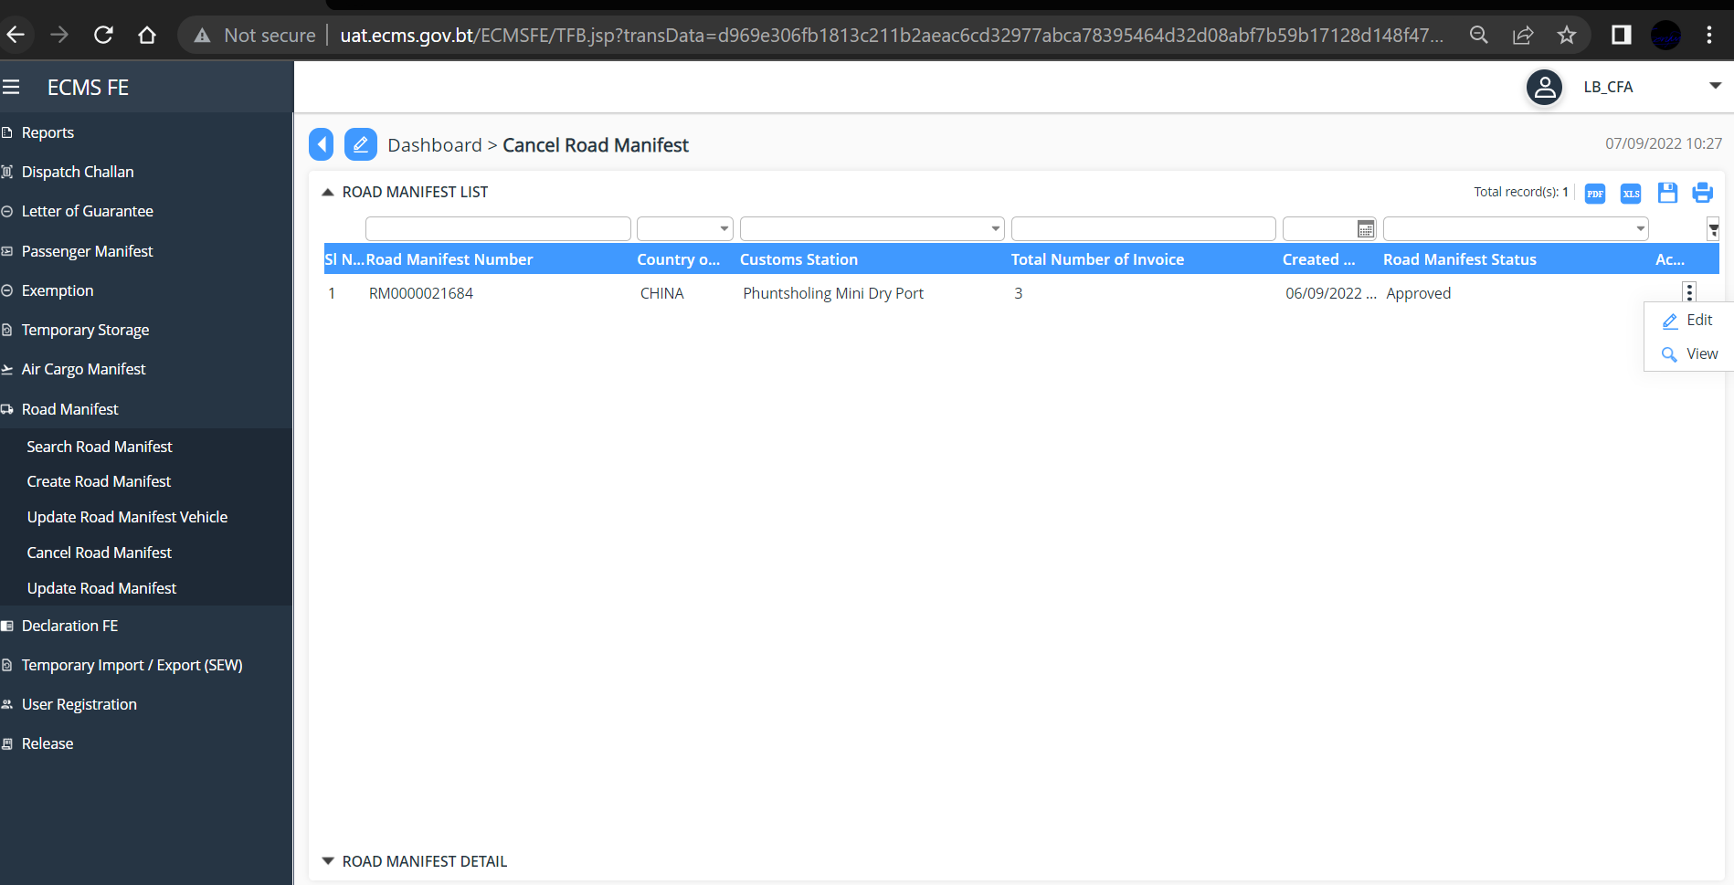
Fig. 18. Cancel Road manifest Dashboard

- Double click on the manifest OR Click on the three dot on the extreme right of the Manifest and click on “Edit” Below Screen is will be displayed
- Select a reason for your cancellation from the dropdown list
- Add your Remarks and Click “Cancel Manifest” Button to Submit.

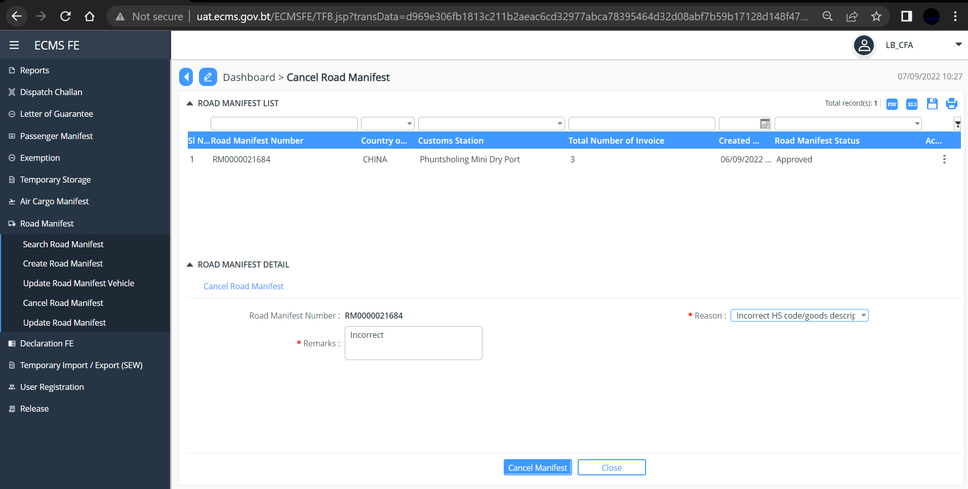
Fig. 19. Submit Cancel Manifest RequestUpdate Road Manifest

D. Update Road manifest

- Go to Road Manifest in the menu and select “update Road manifest” , subsequent screen is displayed with your road manifest list.
- Or Search your Road Manifest by your Road Manifest Number
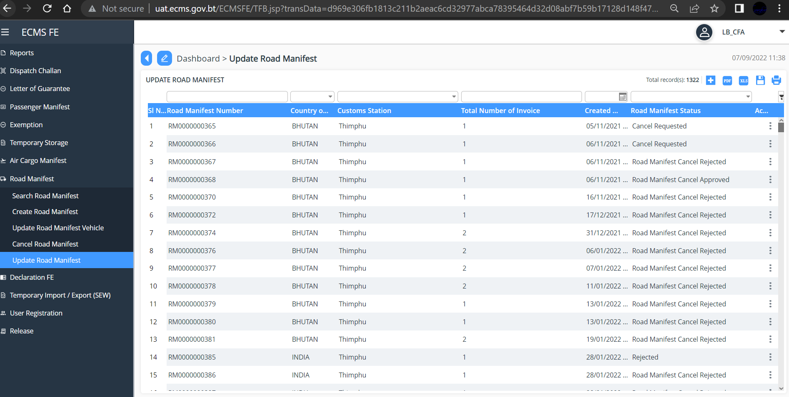
Fig.20. Update Manifest Dashboard

- Double click on the manifest to view the manifest details. The details are shown as below. Update the details and click update to submit.
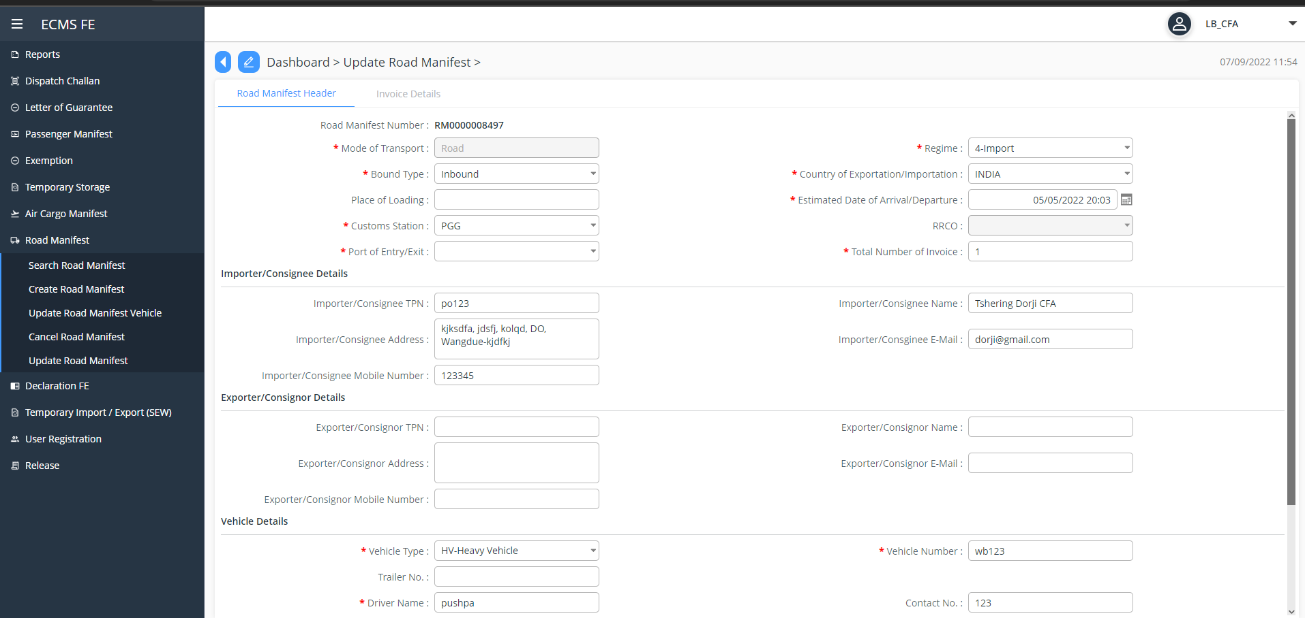
Fig. 21. Update Road manifest

Chapter 4- Logging Out

- This function allows the user to log out from the application any time. User can sign out from the eCMS System any time by simply clicking the “Logout” button available in from the dropdown at the upper right corner of the user logged-in window.

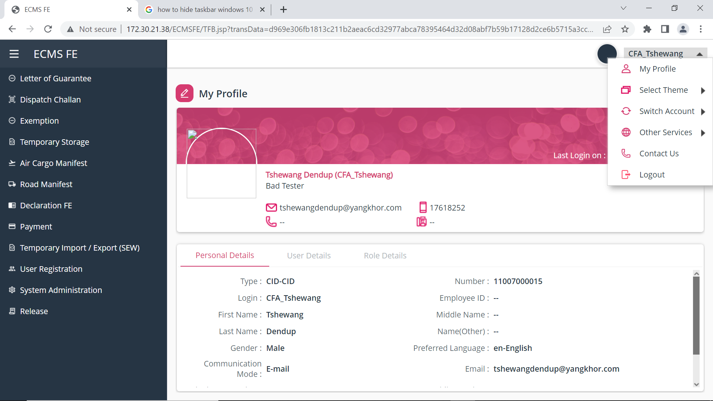
Fig.14. Log Out Page

